

QUANTUM OF FINANCIAL CONTRIBUTION -2020-21

|  |  |  |
| --- | --- | --- |
| **YEAR** | **NO OF ENROLLED ALUMNI** | **ALUMNI CONTRIBUTION IN RUPEES** |
| 2020 -21– APHRODONS | **73** | **Rs 36, 500** |
| **TOTAL** | **73** | **Rs 36, 500** |

Secretary Treasurer

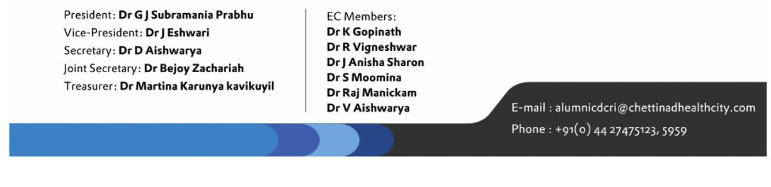



|  |  |  |
| --- | --- | --- |
| S.NO | ALUMNI NAME | FINANCIAL CONTRIBUTION IN RUPEES |
| 1 | AARTHY.K | Rs 500 |
| 2 | AKANSHA TINI.P | Rs 500 |
| 3 | AKSHAYA.M N | Rs 500 |
| 4 | ANUREKHA.A | Rs 500 |
| 5 | ASWATHAMAN.P | Rs 500 |
| 6 | ASWINI.S | Rs 500 |
| 7 | BHAVANA.B | Rs 500 |
| 8 | CLEMENT SOLOMON.B | Rs 500 |
| 9 | DEEPIKA.L | Rs 500 |
| 10 | GAYATHRI.S | Rs 500 |
| 11 | GEERTHANA.J | Rs 500 |
| 12 | HARITHA.R K | Rs 500 |
| 13 | HEMALATHA.T | Rs 500 |
| 14 | ILAVARASI.K | Rs 500 |
| 15 | ISWARYA.S | Rs 500 |
| 16 | JOANNA GRACY.P | Rs 500 |
| 17 | KAAVIYA.C | Rs 500 |
| 18 | KAVIYA.B | Rs 500 |
| 19 | KEERTHANA.M | Rs 500 |
| 20 | KEERTHANA.S | Rs 500 |
| 21 | KOKILA.S K | Rs 500 |
| 22 | LAVANYA.M | Rs 500 |
| 23 | MADHUVATHANI.R | Rs 500 |
| 24 | MAHALAKSHMI.V | Rs 500 |
| 25 | MUKILAN.V | Rs 500 |
| 26 | NANDHINI.R | Rs 500 |



|  |  |  |
| --- | --- | --- |
| 27 | NARESH.B | Rs 500 |
| 28 | NIVASHINI.C | Rs 500 |
| 29 | POOJA.L | Rs 500 |
| 30 | POORNIMA.S | Rs 500 |
| 31 | PRATHUSHA.U | Rs 500 |
| 32 | PRAVEEN.R | Rs 500 |
| 33 | RAAVI SRI HARIKA. | Rs 500 |
| 34 | RAJPRITHIVIKA.R | Rs 500 |
| 35 | RAMYA.R | Rs 500 |
| 36 | RANISANTHIYA.S | Rs 500 |
| 37 | RAVEENA.M | Rs 500 |
| 38 | REBECCA ELIZABETH  SUSANNA.J | Rs 500 |
| 39 | REVANTH KUMAR.K K | Rs 500 |
| 40 | RIZVI V CHOUHAN. | Rs 500 |
| 41 | SAI SHRUTHI.H N | Rs 500 |
| 42 | SHAHANA FATHIMA.S | Rs 500 |
| 43 | SHANMADHY.S | Rs 500 |
| 44 | SHANMUGAPRIYAN.D | Rs 500 |
| 45 | SHANMUGAVELU.S | Rs 500 |
| 46 | SHARMISTA SREE.K | Rs 500 |
| 47 | SIDDHARTH.A | Rs 500 |
| 48 | SIDHAARTH.R | Rs 500 |
| 49 | SIVANDHINI.P S | Rs 500 |
| 50 | SONU.R | Rs 500 |
| 51 | SOUNDHAR RAJAN.R | Rs 500 |
| 52 | SRIRAM.P | Rs 500 |
| 53 | SRUTHI.S | Rs 500 |
| 54 | STEFFY.S | Rs 500 |
| 55 | SUBHASHINI.R | Rs 500 |
| 56 | SUMITHRA.M | Rs 500 |
| 57 | VALARMATHI.M | Rs 500 |



|  |  |  |
| --- | --- | --- |
| 58 | VIGNESH.R | Rs 500 |
| 59 | VINITHA.A | Rs 500 |
| 60 | VISANTH.P | Rs 500 |
| 61 | YAMINI.N | Rs 500 |
| 62 | YUVARANJANI.P | Rs 500 |

EXAM APPEARED FEBRURARY 2020 -PASSED OUT FEBRUARY 2021

|  |  |  |
| --- | --- | --- |
| 63 | YUGANTHI.D | Rs 500 |
| 64 | PAVITHRA.L | Rs 500 |
| 65 | SAKTHIVEL.A | Rs 500 |
| 66 | DAKSHIN.D | Rs 500 |
| 67 | JEEVAN JOSHUA.G | Rs 500 |
| 68 | KAVITHA.M | Rs 500 |
| 69 | KRITHIKA.R | Rs 500 |
| 70 | METHAF MOHIDEEN.S | Rs 500 |
| 71 | MONISHA.D | Rs 500 |
| 72 | QURATHUL AYN FATHIMA.M J | Rs 500 |
| 73 | SESHA HARI RAM.T M | Rs 500 |